Cynthia Cho

Assignment 2

Due 10/3/2017, Tuesday

**Problem 1**

1.1 Below statements create the 4 tables with their primary and foreign keys as listed.

* PerformanceTypes(PerformanceTypeName) – types of performance
* Performers(PerformerID, FirstName, LastName, Address*, PerformanceTypeName*) – Each performer has a performedID (integer), a name, address and type of performance
* Arenas(ArenaID, ArenaName, City, Capacity)  -- Each arena has an id (integer), a name (Ex. Allstate Center), a city where the arena is located, and seating capacity of the arena
* Concerts(*PerformerID, ArenaID*, ConcertDate) – each concert is given by one performer, on a given arena, at a given date .

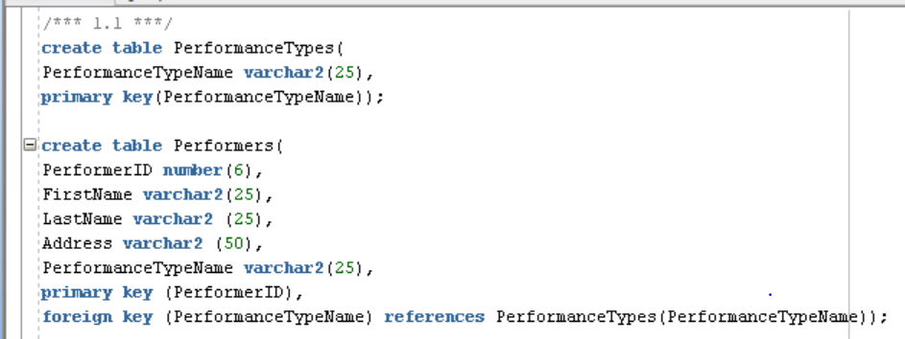

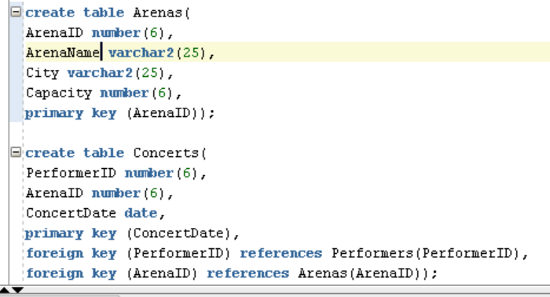

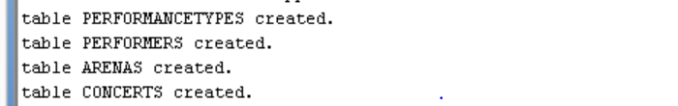

1.2 Records for PerformanceTypes was added.

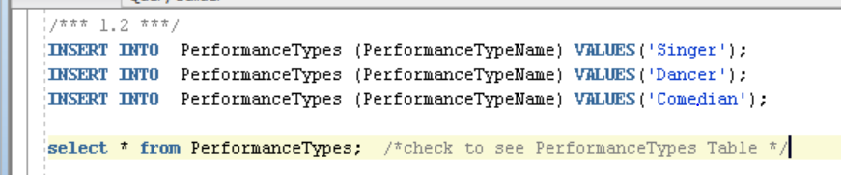

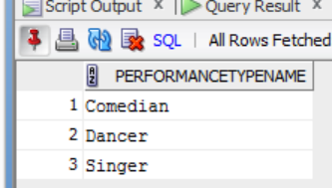

1.3 New column, DateofBirth, was added to the Performers table. This column allows for ‘null’ values.

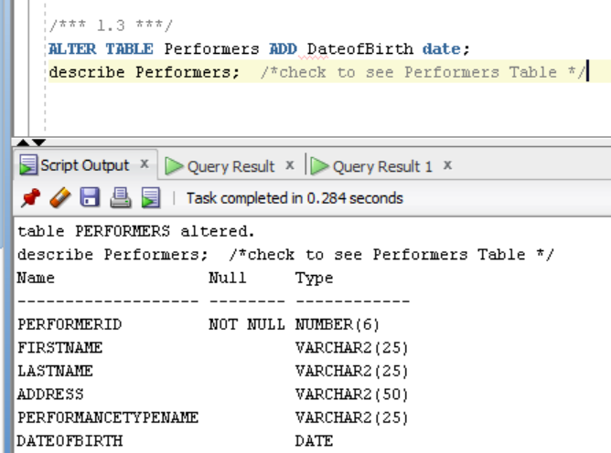

1.4 A record, a row, was added for PerformerID, as shown below.

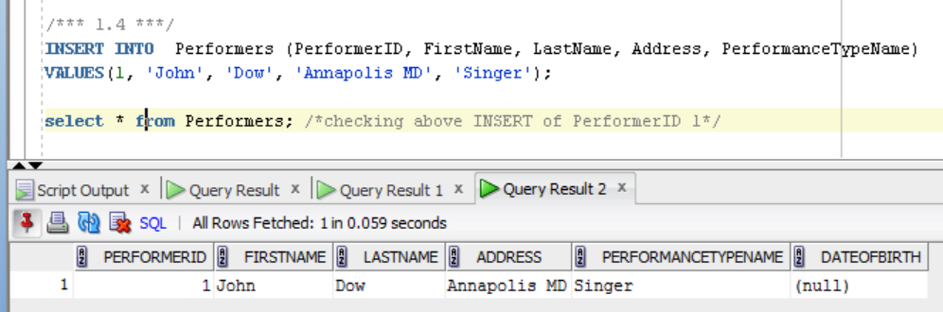

1.5 When trying to add ‘painter’ as a value to the column PerformanceTypeName, because there is no primary key associated with the foreign key, SQL does not allow for this row to be inserted into the Performers table.

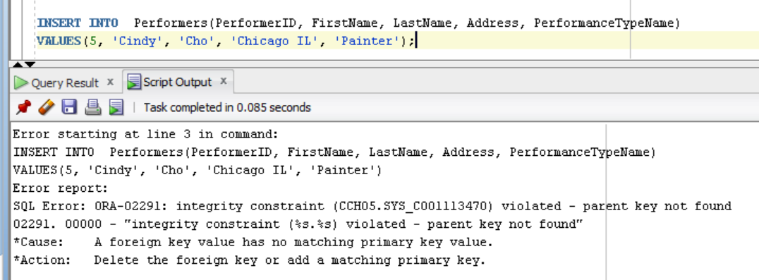

1.6 Three more records were added, as shown below.

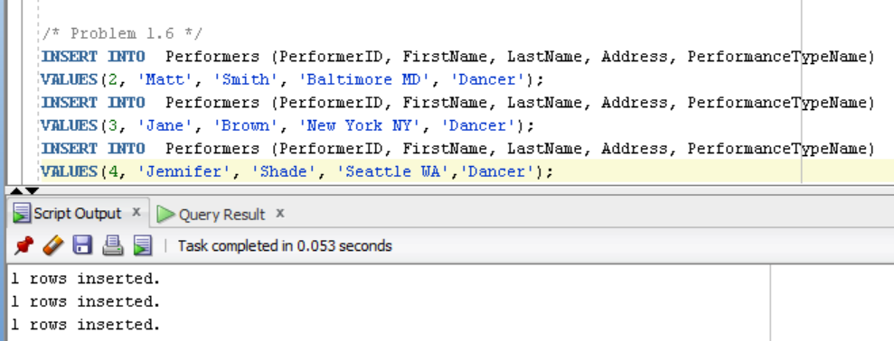

1.7 DateofBirth for PerformerID 1, John Dow, was added as ‘1990-02-02’ using the date format of SQL.

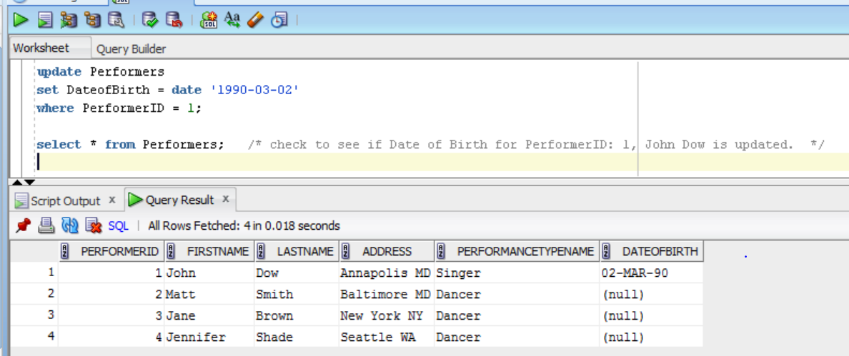

1.8 There are 2 ways to do this, using Matt Smith’s performerID since it is unique and would only get rid of a single ‘Matt Smith’ with the unique PerformerID. But in this case, since there is only one Matt Smith, we can conversely also use the second statement to delete Matt Smith from the Performers table.

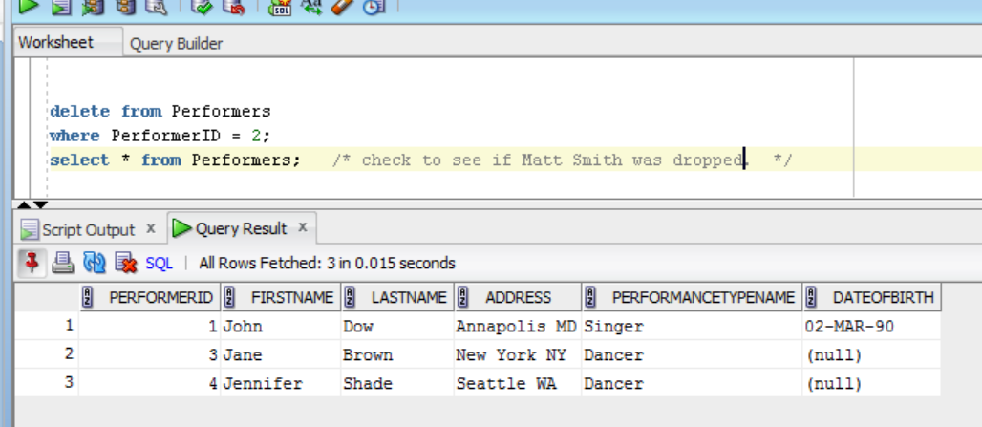

Alternative:

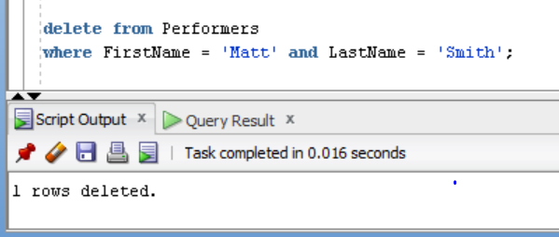

1.9 and 1.10

As indicated by the message below, because the key value of ‘Singer’ was attempted to be deleted where it is a foreign key for the table Performers, SQL will not remove the record in the PerformanceTypes table.

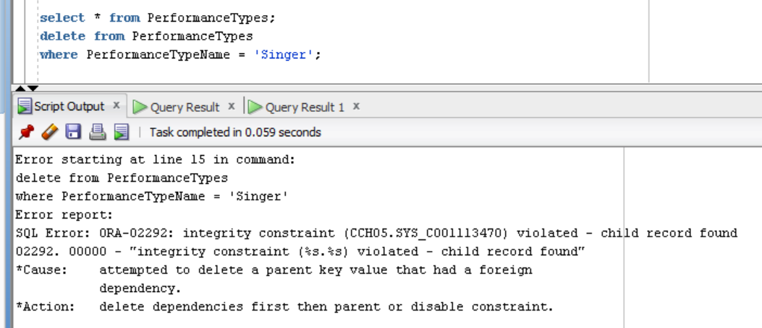

1.11 and 1.12

The query does not succeed in updating PerformanceTypes from ‘dancer’ to ‘dance performer’ because like the previous question, there are dependencies and will not update.

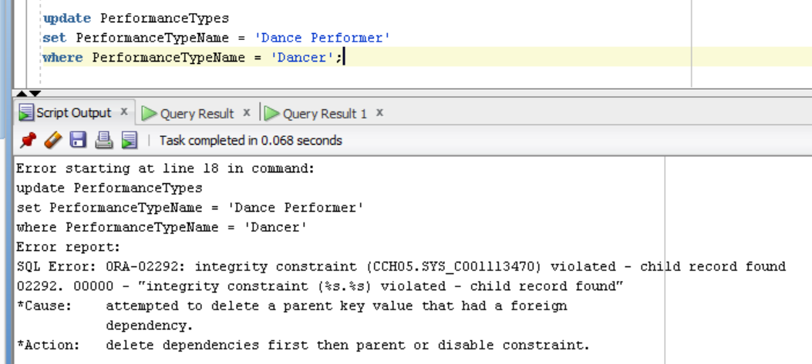

1.13 ArenaIDs were added into the Arena Table.

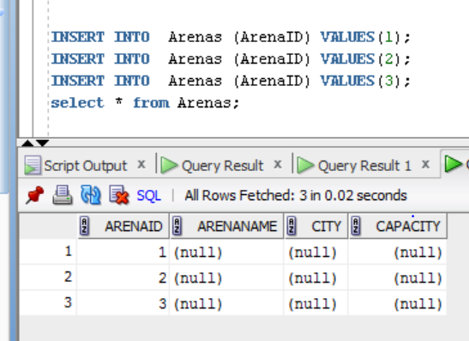

1.14 To work on the question 1.15, the Concerts Table was populated with PerformerID, ArenaID, and ConcertDate.

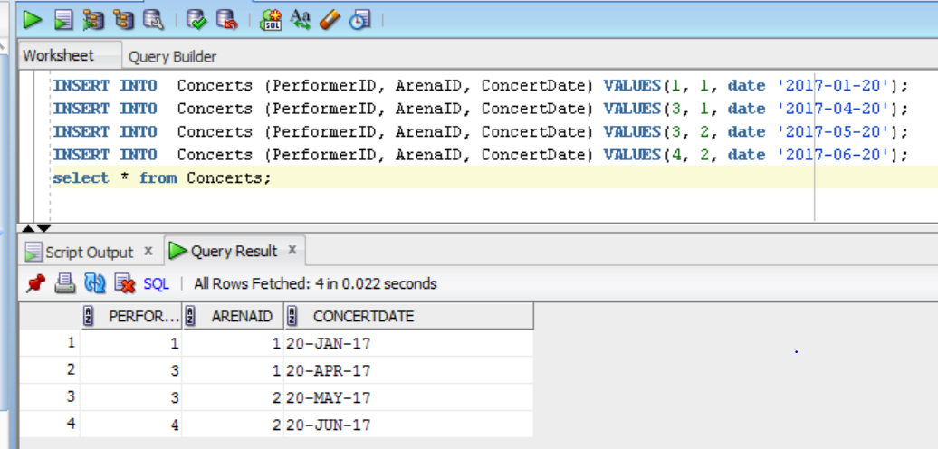

1.15 For this problem, all arenas with at least 2 concert are set to have a capacity of 50,000. Using the Concerts Table above, ArenaID 1 and 2 are set to have to 2 concerts. So taking that information, we update the arena capacity for ArenaID 1 and 2 for 50,000 in the Arenas Table.

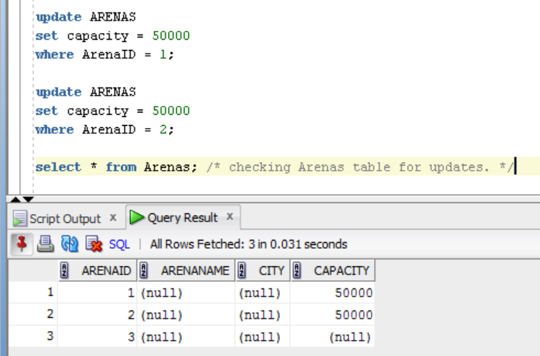

1.16 The table ‘Dancers’ was added with the same structure as the ‘Performers; table.

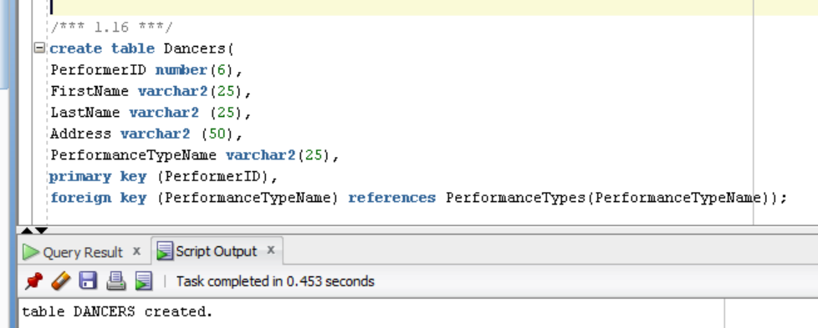

1.17 The table ‘Dancers’ now have records of performers who have ‘Dancer’ as their PerformanceTypeName. And the second table shows us the verification of the added records to the Dancer table.

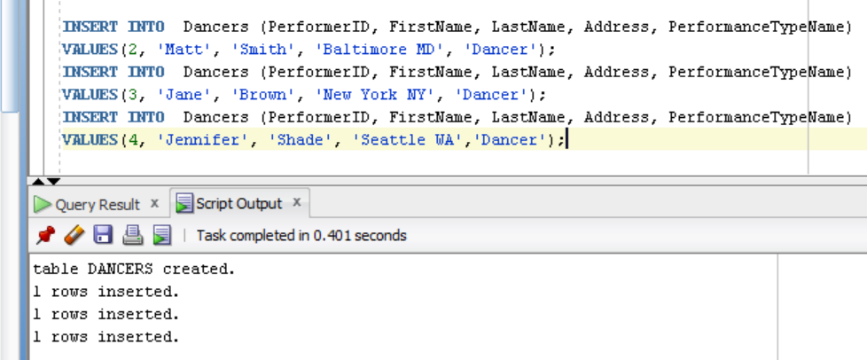

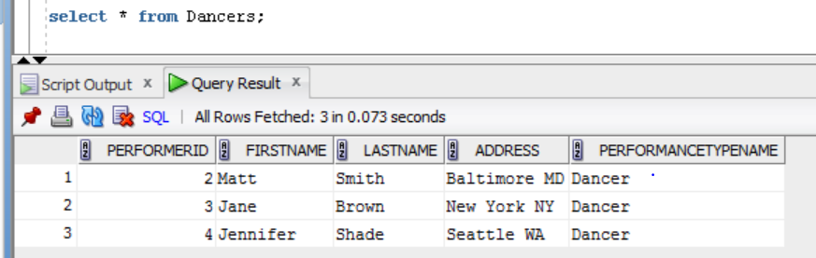

**2. Problem 2 is on the SQL file.**

**Problem 3**

***Table after all rows are inserts, before any data manipulation:***

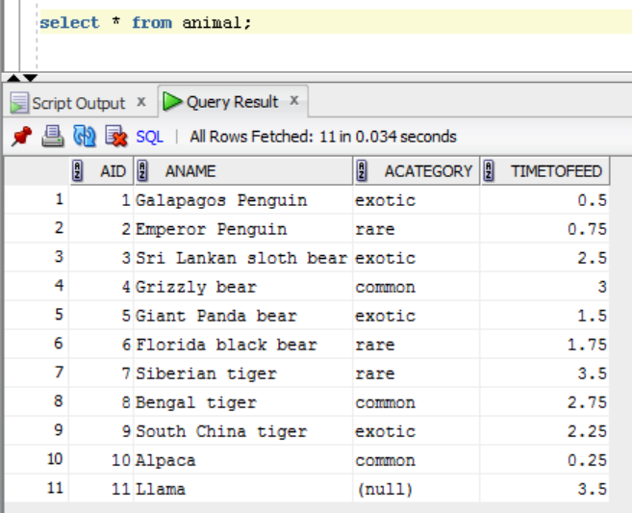

3.1 All the animals (their names) that take less than 1.5 hours to feed (not inclusive).

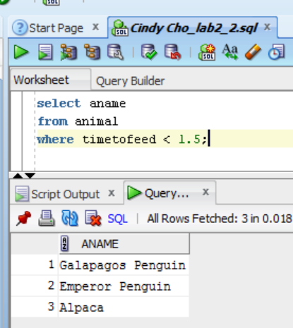

3.2 All rare animals sorted by feeding time (from the least time to the most).

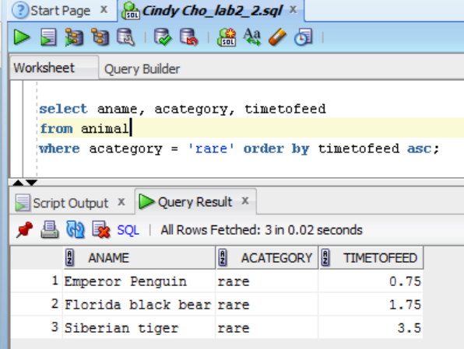

3.3 In this query, I look for the animal names and categories for animals related to the bear using the LIKE operator.

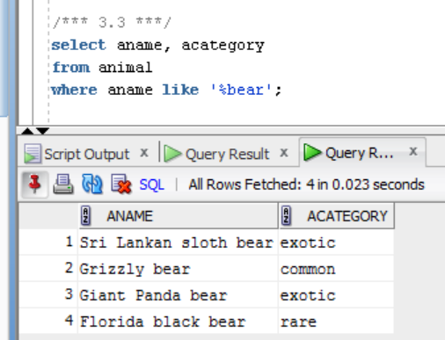

3.4 This statement returns the listing of all animals that have missing rarity values in the acategory column.

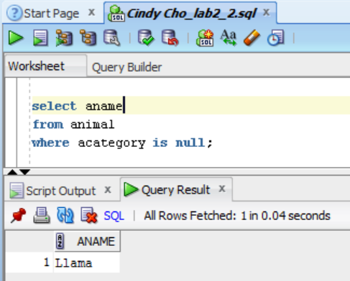

3.5 The query find the rarity rating of the animals, acategory, that take 1 to 2.5 hours to be fed (1 to 2.5 hours are inclusive). I just made it display the timetofeed as a method of double checking that any value not inclusive of the 1 to 2.5 hours was not included in the query.

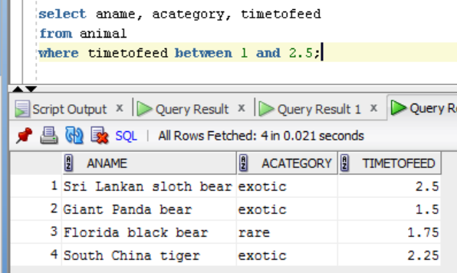

3.6 In this query, I look for all animals related to ‘tiger,’ but are not considered ‘common’ in their rarity category.

